**Homework**  
a) In a simple RGB image, the R, G and B components have the horizontal intensity profiles shown below.  
Answer:

In position 0,the value of color is combination of three colors which are red green and blue(R(0)+G(255)+B(255)). This combination reperesent cyan.

In position N/2,like above it is combination of three colors.so it represent dark yellow in this postion.

In position N-1,represent magneta

b) Draw horizontal intensity profiles for R, G and B components of the image below.

c) Draw horizontal intensity profiles for H, S and V components of the image above.

Answer:

R=[0 255 0 255 0 255 255 0]

G=[0 0 255 255 255 0 255 0]

B=[0 255 0 255 255 0 0 255]

H=[160 200 120 160 80 0 40 160]

S=[0 240 240 0 240 240 240 240]

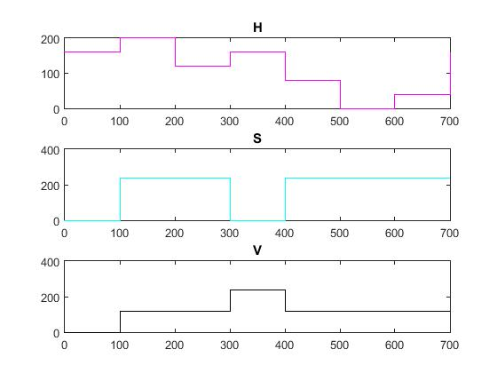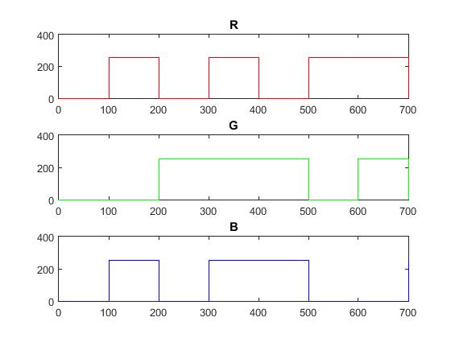V=[0 120 120 240 120 120 120 120]

d) The image below is a 256x256 RGB image. All the colors are pure. The image is converted into HSV color space and one of the components is blurred with a 25x25 averaging mask. Describe what the result would look like if the blurred component is H? S? V?

Answer:

We can see that in border line between green the average in H channel is (80+0)/2=40 which is yellow, so the border in this channel after filter change to yellow.

And also the border between blue and green is (160+80)/2=120 which is cyan.

But in other channels there is no difference between the values so this filter doesn’t affect the color for S and V channels.

|  |  |
| --- | --- |
| **H: 80**  **S: 240**  **V: 120** | **H: 0**  **S: 240**  **V: 120** |
| **H: 160**  **S: 240**  **V: 120** | **H: 80**  **S: 240**  **V: 120** |